**HD-NVR User Manual**

**Directory**

Part one Basic Operation 1

1. Basic Installation 1

1.1 Hard Disk Installation 1

1.2 Mouse Connection 1

2. Starting 1

3.Turn Off 1

4.Login 2

5.Preview 2

6. Remote IPC 3

6.1 Add IPC 3

6.2 Remote Access Config 6

7. Recore Config 7

7.1 Channel Selection 7

7.2 Redundancy 8

7.3 Length 8

7.4 Prerecord 8

7.5 Record Mode 8

Record type 8

8. Record Playback 9

8.1 Record query 10

8.2 Record Play 10

9. Net Work Setting 12

10. Alarm Function 13

10.1 Alarm Function Setting 14

10.2 Linkage settings 15

11. PTZ Control 19

11.1 Basic Setting 20

11.2 PTZ Function Setting 20

12 HDD Information and Management (Support SMR hard HDD) 24

Part two Remote Control 25

1. Web Access 25

1.1 Web Login 25

2. VMS Remote Access 26

3. Cloud Service 27

4. Phone Monitoring 28

Appendix 1. Remote Controller Operation 28

Appendix 2.Mouse Operation 29

This product is an excellent digital surveillance equipment designed specifically for the field of security. Embedded LINUX operating system, making the system more stable; using standard H.264MP video compression algorithms and a unique spatial and temporal filtering algorithm to achieve a high-quality, low bit-rate synchronous audio and video surveillance; powerful network services greatly enhance the ability of network data transmission and remote control capabilities.

# Part one Basic Operation

## 1. Basic Installation

### 1.1 Hard Disk Installation

For the first use，please install the hard disk. The quantity of Hard Disk is based on requirement and specifications of the device。Note: DVR can run and monitor normally without hard disk, while it can’t record and playback.

### 1.2 Mouse Connection

There are 1 USB port at back panel and 1 USB port at front panel, the 2 USB ports could be used for mouse, Flash stick, 3G & WIFI module, mouse connection is depend on products specifications based on different products.

## 2. Starting

Plug the power supply and turn on the power supply switch. Power supply indicator light shining indicates turning on the video recorder. After finishing the startup you will hear a beep, and the default setting of video output is multiple-window output mode.

**Note**: Restart the power after the abnormal power off, DVR will automatically recover the state before power off.

## 3.Turn Off

There are two methods to turn off the DVR which are soft switch and hard switch. Entering [Main menu] and choosing [Logout] in the [turn off the system] option is called soft switch. Pressing the power supply switch is called hard switch.

**Note**: The setting information must be saved before replacing the battery otherwise information will lose.

## 4.Login

When the DVR boots up, user must login and the system provides the corresponding functions with the user purview. There are two user settings which are admin and guest; and they have no passwords. “admin” is the super user purview; “guest” is the common user purview which have right to preview and recording playback. User ”admin” and “guest” can change the password, but can’t change the right.

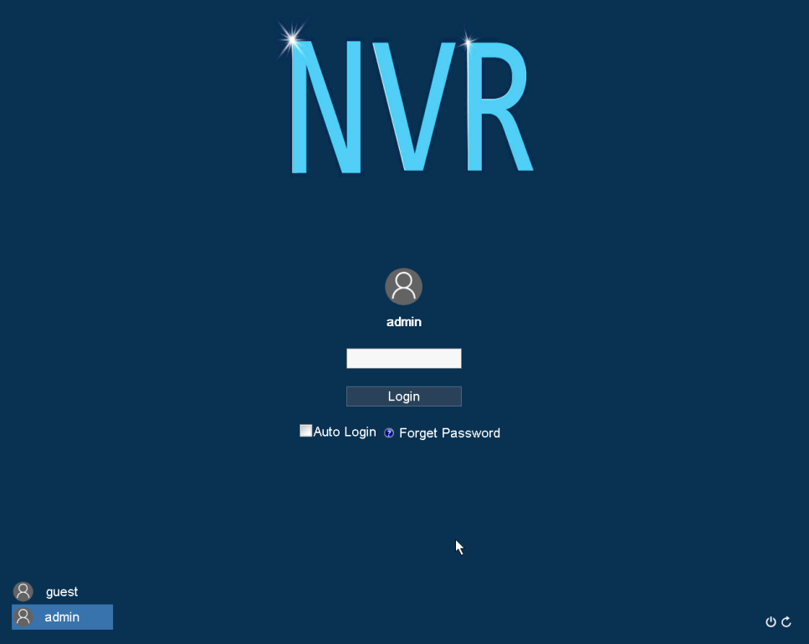

**Password protection:** If the password is continuous wrong seven times, the alarm will start. (Through reboot or after half an hour, the account will be unlocked automatically) For your system security, please modify your password in “User management” after first login.

## 5.Preview

Login normally and choose the multi-menu preview status.The system date, time and channel name are shown in each viewing window. The surveillance video and the alarm status are shown in each window. The normal interface have icons as bellow: channel name, recording mark, audio mark. when trigger alarm, it will be display: video detection, video shelter, video loss and etc alarm mark.

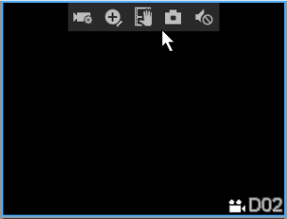

【**Camera**】 Click to enter the camera management page. You can search for, add, edit, and delete IPC, and remotely configure the camera.

【**Partial magnification**】 After clicking, you can click a red box on the preview screen of the channel and then click the red box to enlarge the area. Double-click the mouse to enlarge the area and exit.

【**Burning**】 Need to connect the U disk, start burning and end burning click the button.

【**Snap**】 The usb flash drive must be connected to the mainboard with memory expansion.

【**Audio**】Click to monitor IPC audio and record video files with audio.

## Remote IPC

### Add IPC

Methods：

1.Right click->Camera;

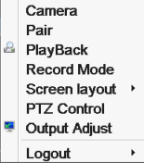

1. Left click Main menu->Camera;

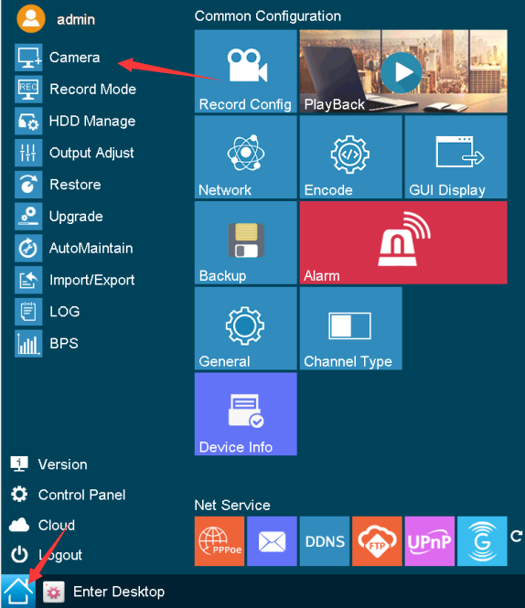

1. Left click Enter Desktop->Double click Camera

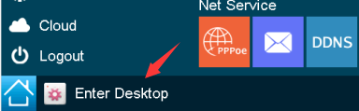

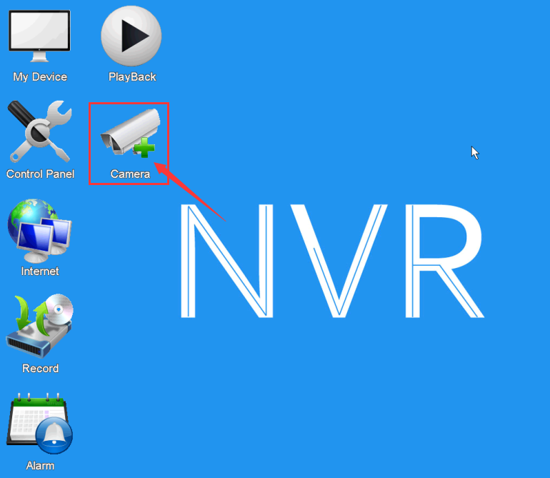

The camera management page is displayed in the following figure by using the preceding three methods:

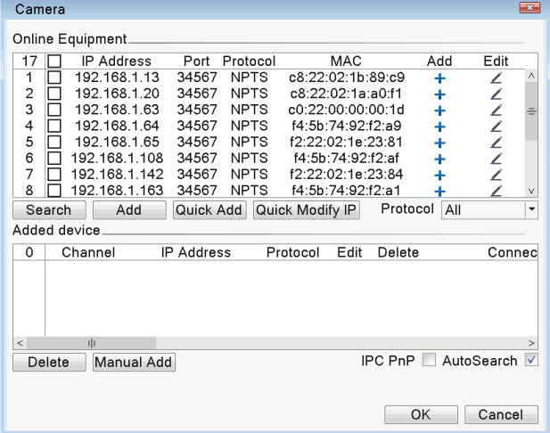

**Online Equipment：**

【**Search**】Click this button to search for online IPC in the local area network.

【**Add**】Check the IPC to be added and click the button to add，You can also click the add icon after the online IPClistboxAddNormalAdd directly or double-click the online IPC to add.

【**Quick Add**】Click the button,According to the NVR network segment, the IP of the online IPC in the LAN is automatically modified and added to the empty channel from small to large.【**Quick Modify IP**】Click the button,Automatically modify the IP of the online IPC in the LAN according to the NVR network segment.

【**Protocol**】Select the protocol for accessing IPC, the general protocol is ONVIF protocol.

【**Modify IP**】Click the edit button behind the IPC in the network online device boxlistboxEditNormal,A dialog box pops up to modify the IPC's IP.

**Added device:**

【**Delete**】Check the added IPC,Click the button to delete,Or click the delete buttonto delete。

【**Manual Add**】Manually add front-end IPC,Choose to add channel, protocol, enter IPC address, port, user name and password.

【**IPC PnP**】After checking this option, the device will automatically change the IP of the same network segment as the NVR and add the online IPC for the unadded channel every one minute.

### Remote Access Config

Select the IPC in the added device box and double-click, or click the edit button behind the IPC, and the remote channel configuration interface will pop up.

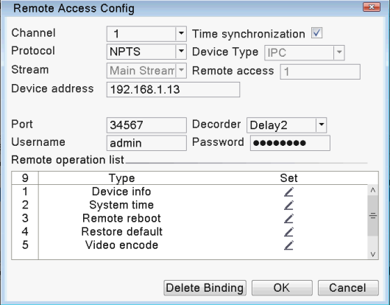

【**Time synchronization**】Synchronize IPC time with local NVR time.

【**Username**】Username to log in to IPC

【**Password**】Password to log in to IPC

【**Delete Binding**】Delete IPC.

**Remote operation list：**

【**Device info**】to check the information of IPC.

【**System time**】to modify IPC time.

【**Remote reboot**】 to reboot IPC.

【**Restore default**】restore IPC default configuration.

【**Video encode**】set video parameter, like resolution, frame rate, bit rate etc.

【**Color settings**】to adjust the image in brightness, contrast, saturation, hue.

【**Machine name**】 to modify IPC name.

**Quick operation:**

In preview interface, click  to add IPC, click  to configurate IPC.

## Recore Config

The video settings mainly include the length of the video, the pre-recording time, and the time period.Find the interface of this function setting through the following ways: Enter [Menu] ->[record] -> [record conf]. The settings displayed on this interface belong to the default settings of the system.

**Note**: at least one hard disk to set as read/write disk.

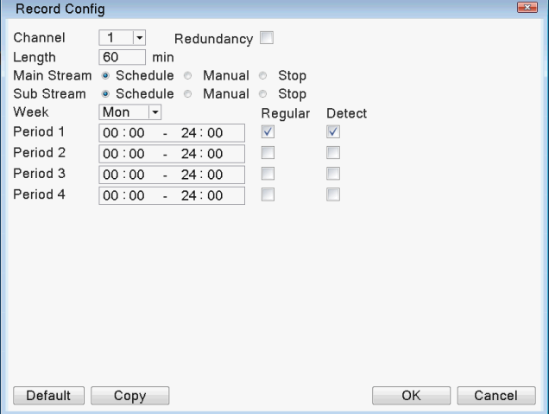

### Channel Selection

Method one:Click the drop-down button with the left mouse button, select the channel number to be set, and select "All" for all channel settings in a unified manner.

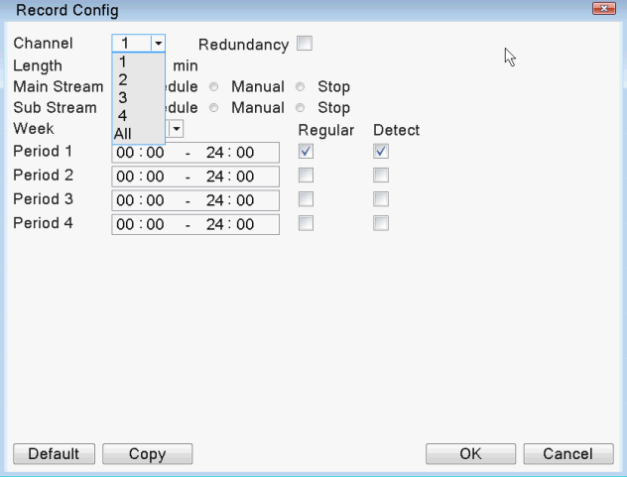

Method two:Place the mouse arrow on the channel number and scroll the mouse wheel to select the channel number to be set.

### Redundancy

Redundancy function is to keep record file double backup. It needs two hard disk to record, one is used as read/write disk, the other is used as redundancy disk.

### Length

Each record file time length is defaulted 60 minutes. (no alarm record produced) .

### Prerecord

Prerecording means detect /alarm record start at the pre-recorded time before alarm signal occurs.

### Record Mode

Recording mode includes: manual, stop, schedule.

【**Manual**】manual record all the time no matter what status the channel is

【**Stop**】no record no matter what status the channel is.

【**Schedule**】if choose this type, need to set record types and time periods.

**Record type**

【**Regular**】record named as “R” . It records by regular type when no special situation occurs in the time you set.

【**Detect**】 record named as “M”. When one of the three signals triggered in the time period you set, which are “motion detect’, “video blind” and “video loss”, it will record by detect type.

【**Alarm**】 record named as “A”. When “alarm input “signal triggered in the time period you set, it will record by alarm type.

**Time period**

Record works in the time period you set.

Set the parameters on week and period. There are four time period which can be continuous or discontinuous or repeated. Three record types are behind each time period to choose.

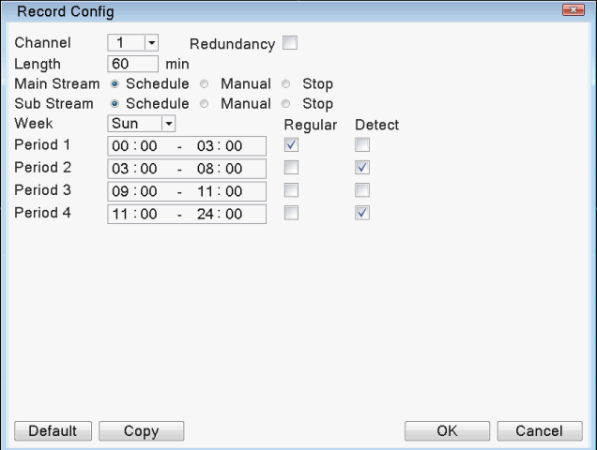

When the user selects the video format, he needs to set each channel according to his own needs. It is recommended to use the default (the default is that the time period is continuous 24 hours, configuration, normal, detection, and alarm are selected at the same time).

## Record Playback

Record playback mainly includes operations such as record query and record file playback.Ways to open record playback:Enter [main menu]->[record]->[playback].

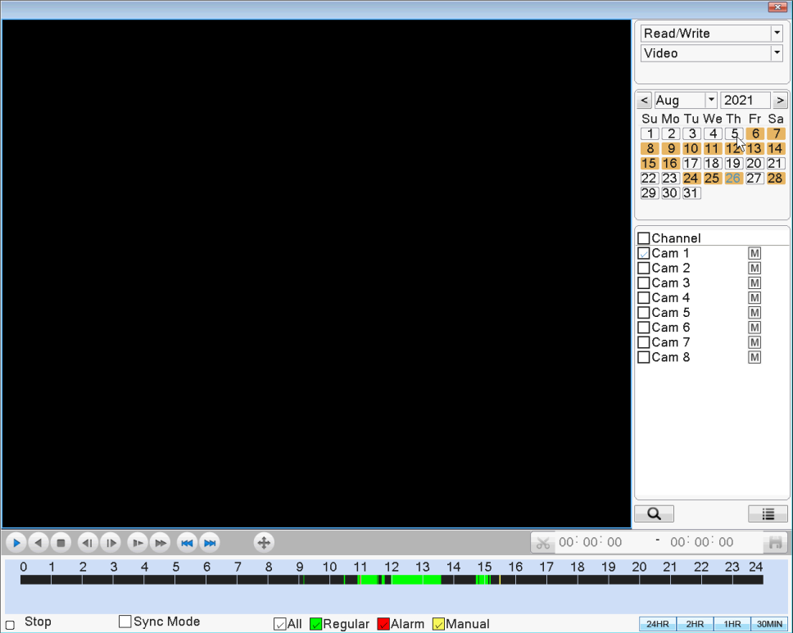

### Record query

After selecting the time period, the device will automatically jump to the selected time,clickto Jump to the query interface.

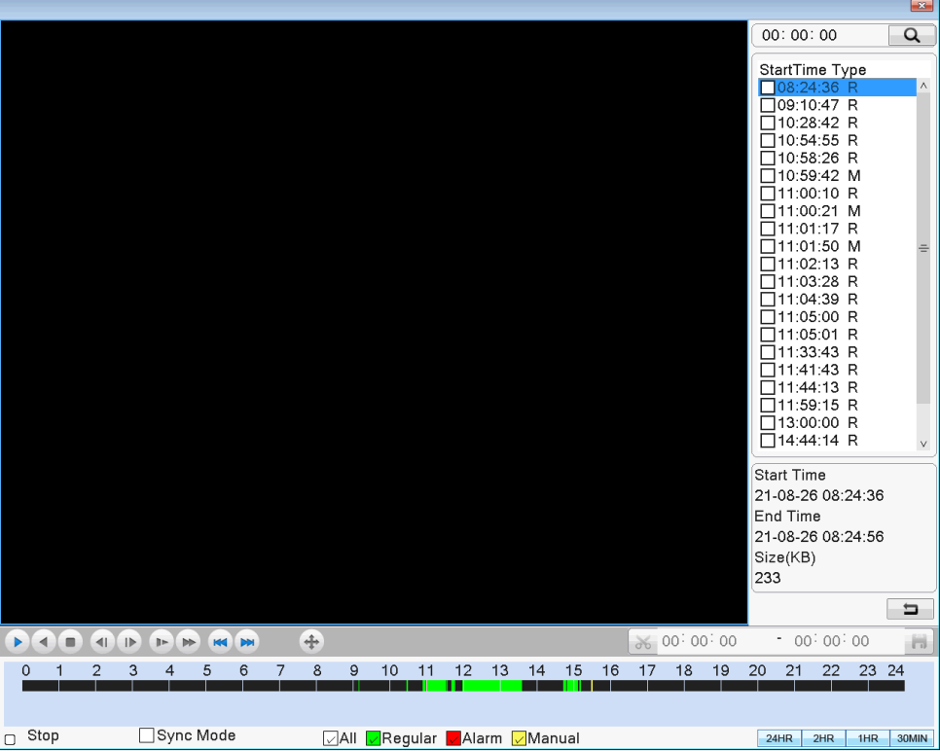

When the video files are different between channels, after selecting the channel, click the query button below the channel to correctly query the video files under that channel.

【**Time period query**】

【**Recording mode query**】

After the query condition is selected, the device will automatically jump. If there is a corresponding recording in the input query condition, the searched recording file is displayed in the list on the right side of the recording playback interface, and the list can hold up to 128 files.

### Record Play

Double click the file in the list which you want to play, or click “play” button.





|  |  |
| --- | --- |
|  | Start Playback |
|  | Play Backward |
|  | Stop Playing |
|  | Slow play |
|  | Fast play |
|  | Prev File |
|  | Next File |
|  | Previous Frame |
|  | Next Frame |
|  | Full Screen |
|  | Cut Back Start |
|  | Backup |

When playback record, you can take the above operation except “previous frame” and “next frame”.

When pause playback, the operation on “previous frame”or “next frame” works.

## Net Work Setting

enter [Main Menu]>[System]>[Network]

【**IP address**】： Set the IP address. Default: 192.168.1.18；

【**Sub net Mask**】：Set the subnet mask code default 255.255.255.0；

【**Default gateway**】：Set the default gateway default 192.168.1.1。

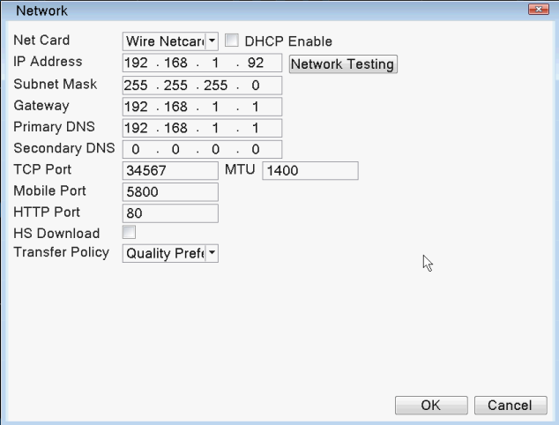

Make the equipment’s IP address and the router in the same network segment. if the router IP address is 192.168.1.1, and the subnet mask is 255.255.255.0, It works by default network setting.generally the default gateway is the router IP address.

By【Main menu】->【Network】or【Enter Desktop】->【Internet】Enter the network service interface as shown below:For the specific settings of each function, please refer to the corresponding instructions for use.

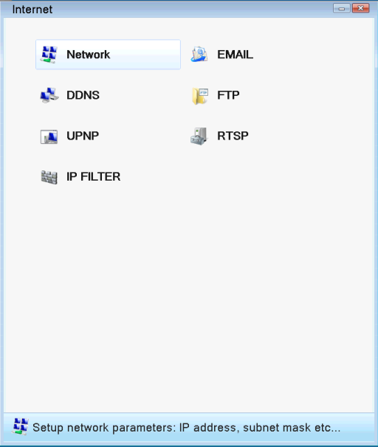

## Alarm Function

The alarm function mainly includes alarm settings motion detect, video loss, video blind and abnormality.

**【Alarm setting】**There are three alarm settings, the function items are basically the same, take motion detection as an example.

The motion detection setting is mainly divided into 2 parts:

Motion detection alarm function setting:Enable,Sensitivity,Region,Period,Interval That is, how to set up to generate an alarm.

Linkage settings for motion detection:Record Channel,Tour,Buzzer,Show Message and some motion detection linkage settings that need to be combined with other function settings (such as linkage video recording, email sending, FTP upload), that is, how to deal with the alarm after the alarm is generated.

Find the interface of this function setting through the following ways:【Main menu】->【Alarm】->【Motion Detect】or【Enter Desktop】->【Alarm】->【Motion Detect】，as follows：

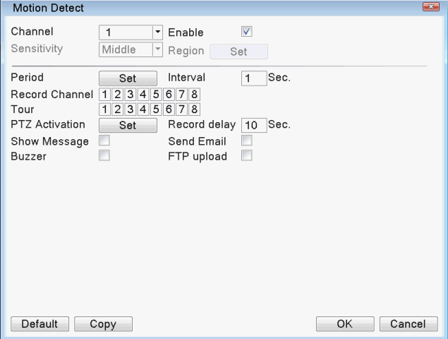

### Alarm Function Setting

First select the channel to be set in the drop-down box behind . 【Enable】 The box at the back is "checked", indicating that the switch is open at the moment, otherwise it is closed. The motion detection can be set only after the enable is turned on.

#### Sensitivity

There are 6 levels in the drop-down box of 【Sensitivity】 . The sensitivity is related to the moving range and intensity of the object. The lower the sensitivity, the higher the requirement for the moving range and intensity of the moving object. The user can select the sensitivity through the drop-down box, the default is "medium". It is recommended that the user select "Highest" to avoid missing the motion detection alarm.

#### Region

Left-click the 【Set】 behind 【Region】, and the area setting interface will pop up. The user can press and hold the left mouse button to select the area that needs motion detection, or click the left mouse button in the box to be selected Select the discontinuous area, where the "red" display area is the area to be motion detection, and the "black area" is the non-detection area. After setting it, exit the area setting interface and the system will save the settings. When the default area is set, it is all the detection area. It is recommended that the user use the default.



#### 10.1.3 Period

Click 【Set】 behind【Period】, and the setting interface will pop up (by default, it is 24 hours detection. It is recommended that users use the default and do not modify). As shown below:

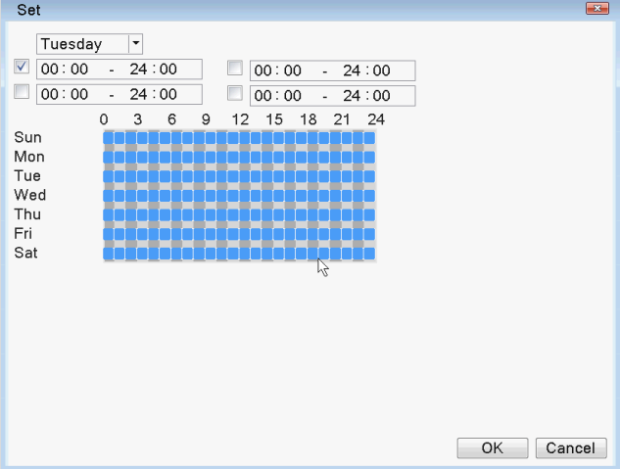

First select the day you want to set in the drop-down box of the week, and then set the time period for that day. Up to four time periods can be set, and these four time periods can be continuous, intermittent, and overlapping. The box in front of the time period is "tick" to indicate that the setting of the time period is valid, otherwise it is invalid.

Note: The set time period corresponds to the time period displayed in the Gantt chart below. After setting, click 【OK】 to save and return to the previous level. Click 【Cancel】 to cancel this setting and return to the previous level.

#### 10.1.4 Interval

Within the set interval (default is 1 second), if multiple motion detection occurs, only one alarm signal will be triggered.

### Linkage settings

The linkage setting is mainly the processing action setting after the alarm is generated.

#### Record Channel

The function of the recording channel is that when motion detection occurs in this channel, the selected recording channel will perform motion detection recording and package it into a recording file of file type M. The choice of recording channel can be one-to-one or one-to-many. When the box corresponding to the channel is "blue", it is selected, otherwise it is not selected. The following two pictures are for channel 1 (one-to-one). ), and channel 2 (one-to-many) recording channel settings. Generally, it is recommended that users choose one-to-one video recording.

One-to-one:It means that when the channel generates an alarm, only this channel is linked for recording. For example, when channel 1 generates an alarm, the corresponding channel generates linkage recording during a period of time, and it is packaged into a recording file of file type M.

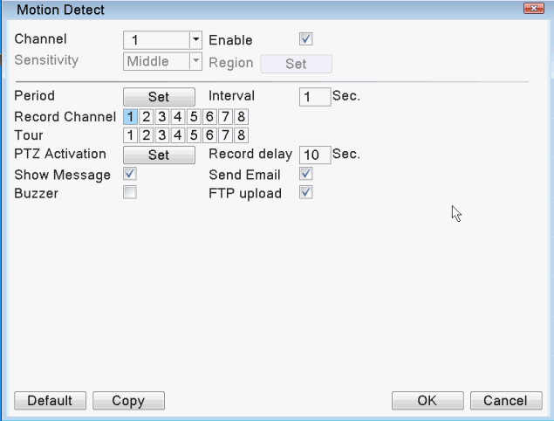

One-to-many:It means that when the channel generates an alarm, the selected channel is linked to record. For example, when the channel 2 generates an alarm, the selected channel (1, 2, 4, 5, 6) is linked to record, and the file type is packaged as M's video file.

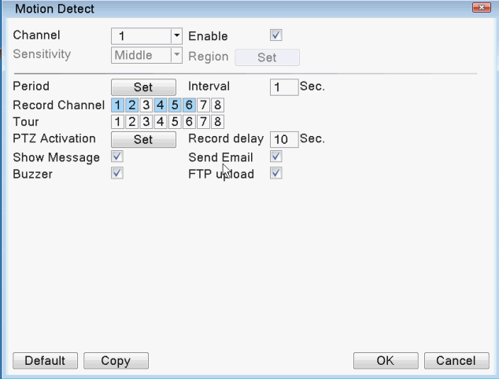

【Record delay】:Recording delay refers to the period of time from the start of linkage recording to the end of the alarm when an alarm signal is generated, that is, the set 【Record delay】 time, the default is 10 seconds. The range is 10-300. As shown in the figure below, the recording delay is set to 300 seconds: Explanation: After a moving object passes by, it will link the recording to generate an M file. After the alarm stops, it will continue to link the recording with a delay of 300 seconds before stopping.

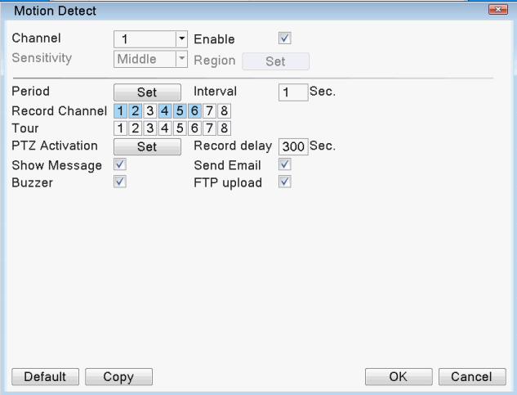

#### 10.2.2 Tour

Round tour refers to the channel selected in the channel number. When there is an alarm signal, the selected channel will be previewed in a single-screen round tour. Here you can arbitrarily select one or more of the channels for round robin. For example, in the setting shown in the figure below, channel 123456 is selected for round robin:

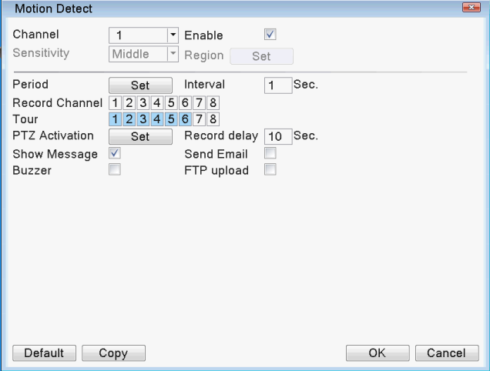

#### 10.2.3 PTZ Activation

When an alarm occurs, the PTZ of the set channel will be linked.

Click the setting behind 【PTZ Activation】, and the setting interface will pop up as follows:

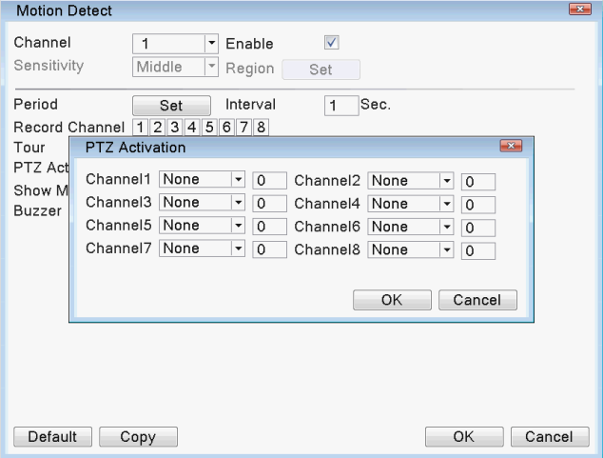

Note: PTZ Activation, need to set the preset points, cruise between points, round tour and other parameters in 【left-click】-> 【PTZ Activation】

#### 10.2.4 Send Email

【Send Email】The box "tick" is selected, which means that an email will be sent to notify the user at the same time when an alarm occurs.

Note:TO send email，need to set by【Main menu】->【Email】or【Enter Desktop】->【Internet】->【Email】 .As follow:

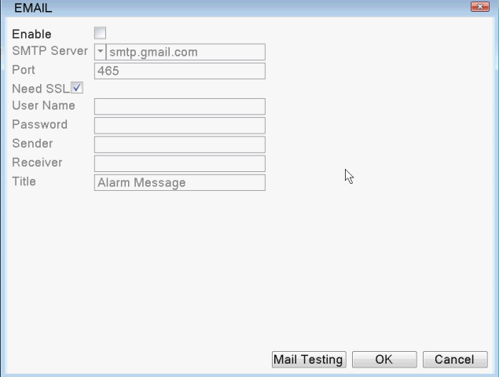

#### 10.2.5 Show Message

The function of the screen prompt is that when an alarm signal is generated, the screen of the local device will prompt 【Alarm Status】, and click 【OK】to end this prompt. 【Screen prompt】 When the box behind it shows "tick", it is selected, otherwise it is not selected.

#### 10.2.6 Buzzer

When an alarm signal is generated, the local device side will generate a buzzer for a period of time. 【Buzzer】 When the box after "tick" is displayed, it is selected, otherwise it is not selected.

#### 10.2.7 FTP upload

【FTP upload】The box "tick" is selected, which means uploading to FTP at the same time when an alarm occurs.

Set ways:【Main menu】->【FTP】or【Enter Desktop】->【Internet】->【FTP】,for example:

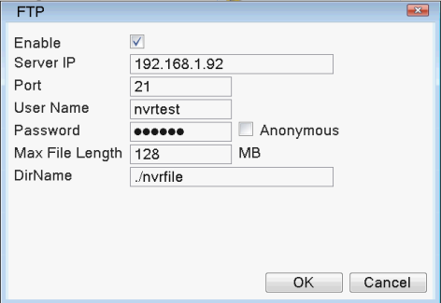

## PTZ Control

The main functions of PTZ control include: control PTZ direction, step length, zoom, focus, aperture, operate preset points, cruise between points, patrol, line scan boundary, auxiliary switch, flip, horizontal rotation, etc.

Find the interface of this setting function setting through the following ways: directly click the right mouse button on the preview interface and find 【PTZ Control】, the interface is as follows:

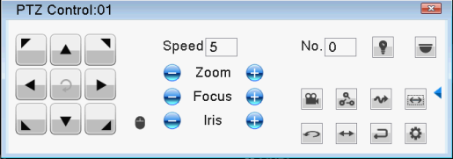

### Basic Setting

PTZ control as follow:

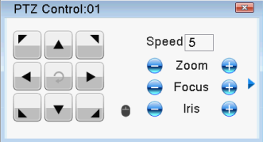

【Control Direction】 to turn in eight different directions

【Speed】 speed of PTZ turning

【Zoom】 adjust camera magnification by /

【Focus】 narrow camera focus by adjusting /

【Iris】adjust camera iris by /

【PTZ trace】 press mouse left key, PTZ turn quickly.

【Set】set about PTZ function

### PTZ Function Setting

Click  on the PTZ control interface to enter the function setting menu, as shown below.

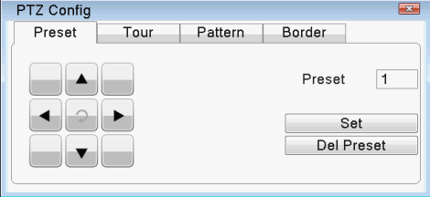

#### 11.2.1 Preset

Set certain position as preset point. Then when call the preset point value, PTZ will turn that position automatically.

1. preset setting

Click  to enter the function setting menu interface of the PTZ, the steps are as follows:

Step 1: Enter the "value" of the preset point in the input box behind the preset point (set a name for the preset point, such as 1, 2)

Step 2:Click the set button to complete the setting of the preset point, that is, the value of the preset point corresponds to the position of the preset point

Step 3: Use the arrow keys to rotate the PTZ to the preset position, and then repeat the first and second steps.

Clear preset point: input the "value" of the preset point, and click the clear preset point button to clear the preset point setting.

1. Call preset

In the figure below, enter the "value" of the preset point in the value input box, and click the preset point button , that is, the PTZ moves to the corresponding preset point.



#### 11.2.2 Tour

The cruise line connected by multiple preset points, call the cruise between the points, the PTZ runs repeatedly on the set cruise line.

1. Tour setting

Click  to enter the function setting menu interface of the PTZ, the setting steps are as follows.

Step 1:Set several preset points, the method is the same as the above preset point setting steps;

Step 2:Click the cruise button between points, enter the preset point value in the preset point dialog box, and click the add preset point button to set the specified direction as one of the preset points for cruise between points; enter cruise in the cruise line dialog box Line value.

Clear presets:Enter the number of preset points and click the Clear Preset Point button to clear the preset point settings.

Clear cruise line:Enter the number of cruise lines, and click the clear cruise line button to clear the clear cruise line point settings.

As follows:

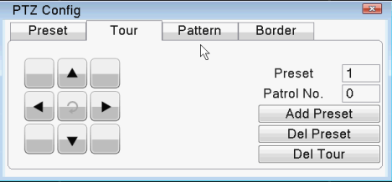

1. transfer point tour

In the figure below, enter the cruise value between points in the value input box, and click the cruise button between points, that is, the PTZ will run repeatedly on the cruise route.



#### 11.2.3 Pattern

By operating the PTZ, set a patrol route, call the patrol, and the PTZ will run repeatedly on the set patrol route.

1. Pattern Setting

Click  to enter the function setting menu interface of the PTZ, the setting steps are as follows.

Step 1:Click the "pattern" button to enter the patrol function setting interface;

Step 2:Enter the value in the box after the patrol, and click the start button;

Step 3:Enter the PTZ control interface to perform a series of operations such as zoom, focus, aperture or direction;

Step 4:Return to the patrol function setting interface and click the end button to complete the setting, that is, the patrol value corresponds to the corresponding route.

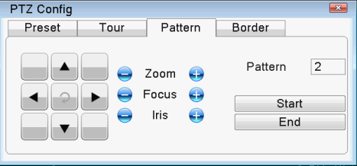

1. Pattern Transfer

In the figure below, enter the number of patrols in the value input box, click the patrol button, that is, the PTZ will run according to the set route, and click the arrow key to stop.



#### 11.2.4 Border

On the horizontal line, set a route, call the line scan, and the PTZ will run repeatedly according to the set route.

1. Border Setting

To set a certain horizontal arc as the track searched by the gimbal, the steps are as follows:

Step 1:In the PTZ control interface, manipulate the arrow keys to turn the PTZ to the specified position, click the set button to enter the PTZ setting interface, select the left boundary, and return to the PTZ control interface;

Step 2:Control the direction key to select the specified location, click the set key to enter the PTZ setting interface, select the right boundary point, and return to the PTZ control interface;

Step 3:Complete the setting, that is, set the position to the left boundary and the right boundary.

Note: The left and right borders are on the same horizontal line, and the pan/tilt will rotate in the opposite direction from the left border point to the right border point for circular rotation; the left and right borders are not on the same horizontal line, and the pan/tilt is only at the end of the horizontal trajectory line connected to the left border point As the right boundary point, rotate in the opposite direction from the left boundary point to the right boundary point, and perform circular rotation.

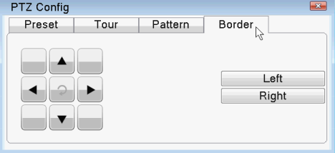

1. Border Transfer

In the figure below, click the line scan button, the pan/tilt will operate according to the set route.



#### 11.2.5 Horizontal rotation

Click the horizontal rotation button, the pan/tilt will rotate horizontally (rotate horizontally relative to the original position of the camera).

#### 11.2.6 Flip

Click the flip button to flip the PTZ.

#### 11.2.7 Reset

The PTZ restarts, and all set data are reset to zero.

#### 11.2.8 Page Switching

In the PTZ control interface, click the auxiliary switch button to enter the following figure to set auxiliary functions. The auxiliary number corresponds to the auxiliary switch on the decoder.

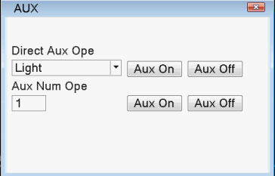

## 12 HDD Information and Management (Support SMR hard HDD)

The hard disk is mainly divided into two parts:

Hard disk information query: you can check the hard disk type, total capacity, remaining capacity, hard disk status and hard disk recording time.

Find the function setting interface of this device through the following ways:【Enter Desktop】>【My Device】>【HDD Info】as follow:

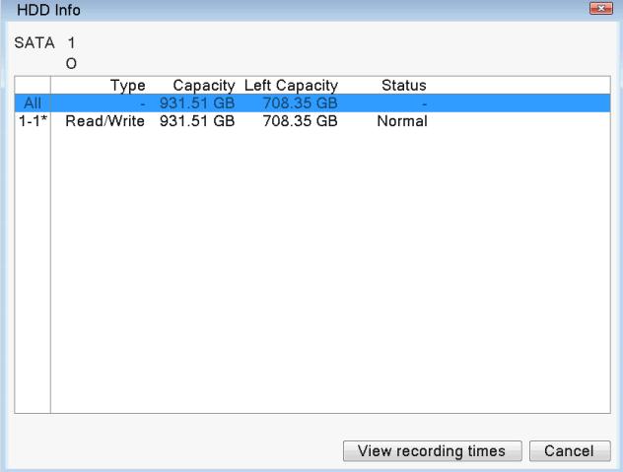

HDD management settings:The hard disk can be set as a read-write disk, read-only disk, redundant disk, and the hard disk can be formatted to recover from errors. Ways:【Enter Desktop】>【Control Panel】>【HDD Info】，or【Main menu】>【HDD Info】as follows:

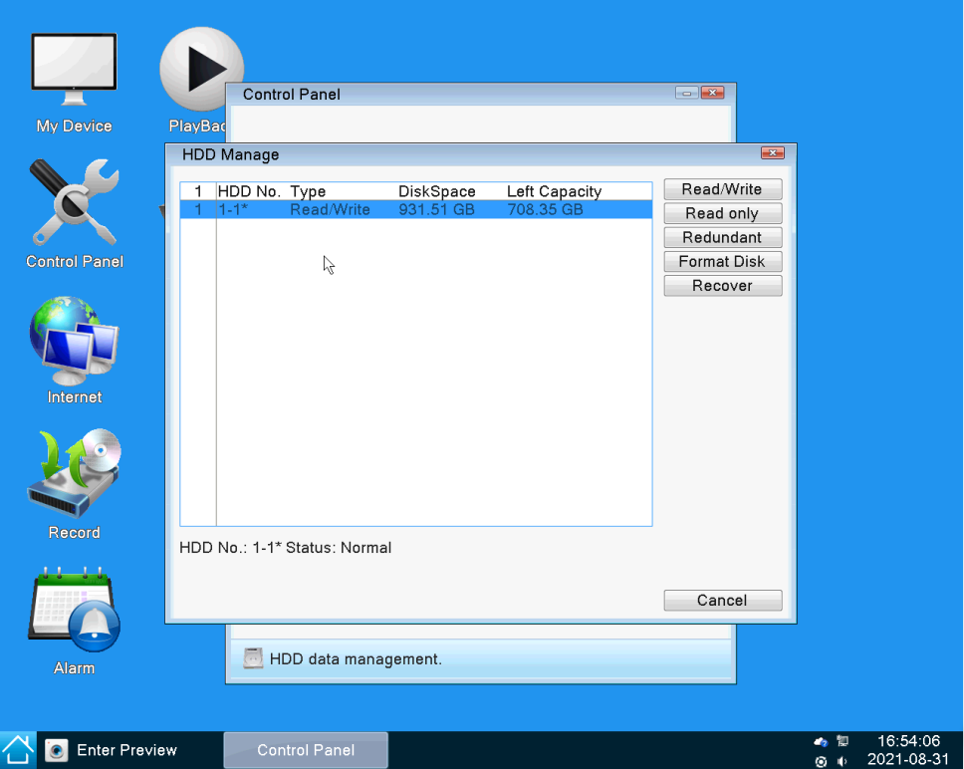

# Part 2 Remote Control

Enter the IP address set by the product in the browser to remotely access the device. During network remote monitoring, due to the influence of the network, you need to download and install the control for the first time, and individual products need to use the CD or manually install the plug-in. Otherwise, you cannot log in to the device remotely.

## Web Access

### 1.1 Web Login

After the network is connected, use the browser that comes with the PC, enter the IP address of the device, and log in to the device for remote monitoring. For specific operations, see the instructions for use on the WEB client.

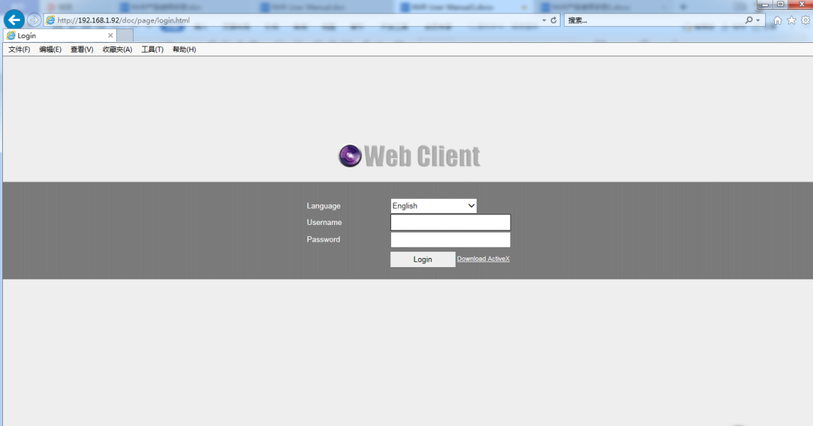

Web Login Page

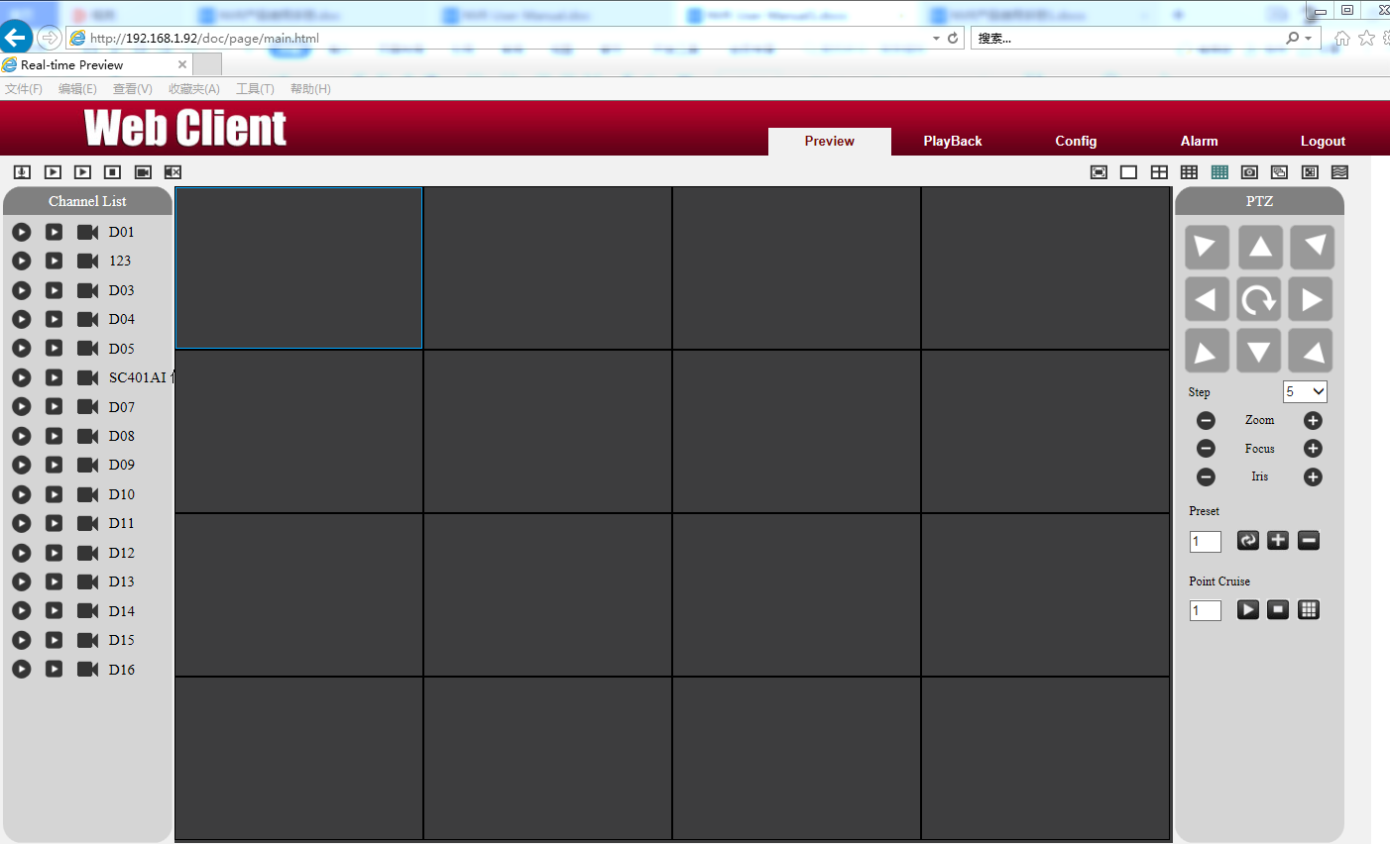

Web Main Page

## VMS Remote Access

VMS is a professional software used for remote monitoring of multiple devices. It has the advantages of security, convenience, stability and unified management of multiple devices, and it is easy to install without downloading plug-ins. It is recommended that customers use it. See the VMS manual for specific operations.

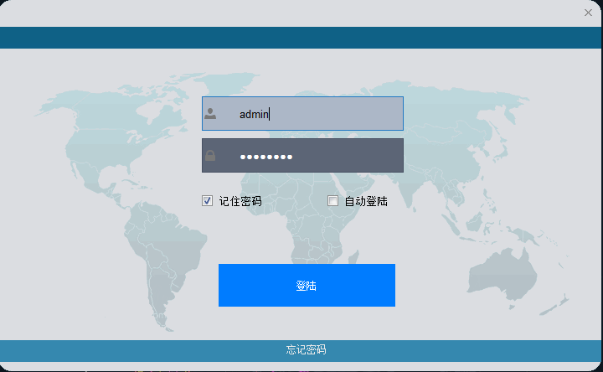

VMS Login Page

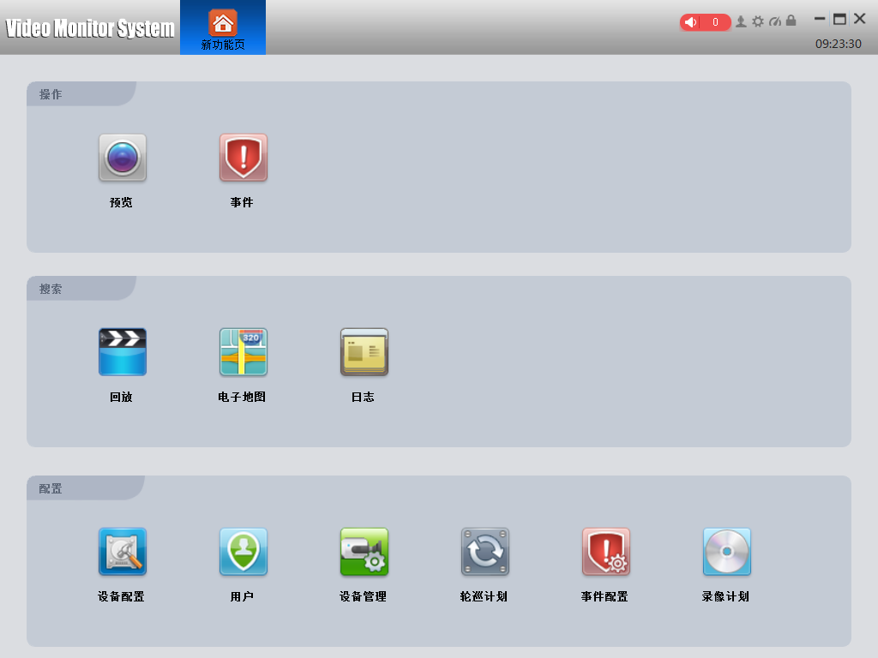

VMS Main Page

## Cloud Service

By Cloud server, no mapping port, only need device ID, then you can remotely access the device directly. For more details please refer to Cloud server user manual.

Open the IE browser, enter http://www.topscloud.net, and log in to the cloud service web client. You can register an account, log in by user, or log in directly with the device ID. For specific operations, see the cloud service user manual.

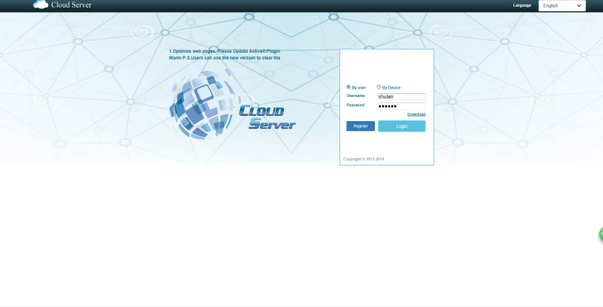

## Phone Monitoring

The device turns on the mobile phone monitoring function by default.

Mobile phone monitoring software：XVRView

Mobile phone monitoring port: 5800

For specific operations, please refer to the mobile client instructions.

# Appendix 1. Remote Controller Operation

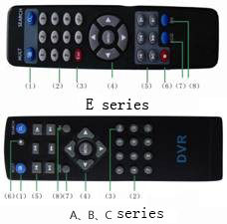

|  |  |  |
| --- | --- | --- |
| **Serial number** | **Name** | **Function** |
| **1** | **Multi-channels button** | **Multi-channels preview** |
| **2** | **Number button** | **Password input/number input/ channel switch** |
| **3** | **【Esc】** | **Back to up window** |
| **4** | **Direction button** | **Direction and OK button** |
| **5** | **Playback operate** | **Playback Basic operation** |
| **6** | **Record control** | **Enter into record menu** |
| **7** | **Remote controller** | **Input the number of DVR to control it** |
| **8** | **FN** | **Assistant function** |

# Appendix 2.Mouse Operation

*Take right hand as an example

|  |  |
| --- | --- |
| **Operation** | **Function** |
| **Double left click** | **Double click one item in the file list to playback the video**  **Double click the playback video to zoom in or out the screen** |
| **Double click the channel to make it full screen display in preview**  **double click again back to the multi-channel display** |
| **Left click** | **Choose according option in the menu** |
| **Right click** | **Pop up desktop shortcut menu in preview interface** |
| **Pop up shortcut menu when operating menu** |
| **Wheel button** | **Add or subtract number value in the number setting** |
| **Switch the items in the combo box** |
| **Page up or down in the list** |
| **Move mouse** | **Choose the widget or move the item in the widget** |
| **Drag mouse** | **Set the motion detect area** |
| **Set the cover area** |

**Thank you for reading, if you have any questions please contact us.**